# Cost and Effort Estimation

## Function Point Approach

### Introduction

The Function Point estimation approach, is based on the amount of functionalities in a software and their complexity. Function Point estimators are useful since they are based on information that are available early in the project life cycle.

In order to perform this estimation, it is necessary to identify in the project these functional type: Internal Logic File, External Logic File, External Input, External Output, and External Inquiry. Then for each of these types, it is needed to define the complexity and evaluate the cost using the appropriate weight.

To define the weights value we have used this table:

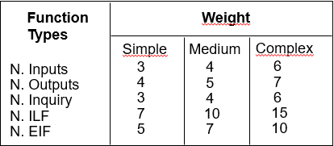

### FP Estimation

#### Internal Logic File

The system includes a number of ILFs that are used to save and managed information about:

* **User** The system saves only these simplex information: name, surname, phone number, mail address, username and password
* **Taxi Driver** The system stores and uses these information: personal information like for the user, id, and the related information (id, position) about the associated taxi
* **City Zone** The system uses the geographical information and the adjacency among each zone. Due to the possible high complexity of the data structure storing the adjacency this ILF can be consider Complex
* **Request** The information stored for each of them are different depending on the type:
  + **Normal Request** Origin and identifier of the requestor
  + **Reservation** Origin, identifier of the requestor and date and time
  + **Shared Request** Origin, identifier of the requestor and destination
* **Ride** The system stores the total fee, the personal info and the info of the associated taxi

Here are shown the complexity and the related weights based on the information written above.

|  |  |  |
| --- | --- | --- |
| ILF | Complexity | FP |
| User | Simple | 3 |
| Taxi Driver | Medium | 4 |
| City Zone | Complex | 6 |
| Request | Medium | 4 |
| Ride | Medium | 4 |

**Total FP for the ILF: 21**

#### External Interface File

The system asks only to an external maps provider the route during the process to evaluate if a new user could join or not an existing shared ride. The complexity of this data strongly depends on the origin/destination point, so the complexity could be evaluated in average medium.

**Total FP for the ILF: 5**

#### External Input

The system interacts both with the user and the taxi driver.

**User operations**

* **Registration/Authentication** These are simple operations related to the possibility to access/register to the system. So the total contribution is : **2x3=6**
* **Request a Taxi** This is the main functionality, the system has to generate the request and handle it immediately in order to send quickly a taxi to the user. So it is possible to consider it of complex complexity. So the total contribution is : **6**
* **Reserve/Delete a Taxi** This operation consists simple in creating/deleting a request. So the total contribution is : **2x3=6**
* **Request a Shared Ride** This is the most complex operation related to the user. In fact, the system has to calculate both if there are other shared rides joinable and the personal fee of each passenger. So the total contribution is : **6**

**Taxi Driver operations**

* **Set his Availability** This operation can be consider as medium because if the taxi driver want to become available the system as to compute in which queue zone he has to be stored. So the total contribution is : **4**
* **End a Ride** This operation is very similar to the availability one, because the system as to compute in which queue zone the taxi driver has to be stored. So the total contribution is : **4**
* **Call Emergency Number/TowTruck/MyTaxiService Operator** These operations are all simplex because are managed directly by the phone application installed in the taxi driver interface. So the total contribution is : **3x3=9**
* **Request Another Taxi** This last operation has the same complexity of the “Request a Taxi” of the user because the system has behave exactly in the same way. So the total contribution is : **6**

**Total FP for the External Input: 47**

#### External Inquiries

The system allows an authenticated user to request information about

* **Personal Information** This feature allows the user to visualize the information stored in the system
* **Pending Reservation** This feature allows the user to visualize all the pending reservation
* **Ride** This feature allows the user to visualize all his ride. They can be a very large number so it can be evaluated as medium complexity

|  |  |  |
| --- | --- | --- |
| EI | Complexity | FP |
| Personal Info | Simple | 4 |
| Pending Reservation | Simple | 4 |
| Ride | Medium | 6 |

**Total FP for the EI: 14**

#### External Output

The system does not provide any services that can be consider of External Output.

**Total FP for the EO: 0**

### Conclusions

|  |  |
| --- | --- |
| Type | FP |
| ILF | 21 |
| EIF | 5 |
| External Input | 47 |
| EI | 14 |
| EO | 0 |
| TOTAL | 87 |

In order to complete the analysis, is it necessary to convert the FP estimation into line of code. But to doing that it’s fundamental knowing the language used for developing the project. Due to the fact that the project was not developed, it has been decided to assume that the project has been written in JEE because the internet-oriented nature of this language is suitable for the project.

Referring to the official FP table <http://www.qsm.com/resources/function-point-languages-table>, the multiplicative value (SLOC/UFP) for JEE is 46.

Now it is possible to convert FP into source lines of code (SLOC) using this formula:

$$SLOC=UFP*\frac{SLOC}{UFP}=87*46=4002$$

## COCOMOII Approach

### Introduction

The COCOMOII approach uses the SLOC size of the project in order to evaluate the effort, the duration and the number of required people taking in account the characteristics of the project but also of staff.

In order to compute the estimation there are two value to define: the Scale Drivers and costs Driver contribution.

All the table used in this analysis have been extract from COCOMOII Model Definition Manual:

<http://csse.usc.edu/csse/research/COCOMOII/cocomo2000.0/CII_modelman2000.0.pdf>

### Scale Drivers

In order to estimate the Scale Drivers value we have used this table

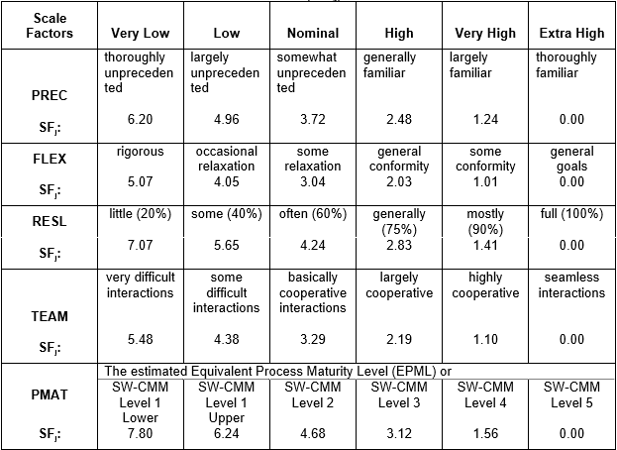

* **Precedentedness** **(PREC)**

This is the first project of this type that the team mate have done, so the PREC is set to Low

* **Development Flexibility (FLEX)**

Due to the fact that the Requirements have been assigned with a general high level of detail, the FLEX is set to High

* **Risk Resolution (RESL)**

The RESL value is set to Nominal because the risk management has been only done textually in this document.

* **Team Cohesion (TEAM)**

This is not the first project that the team has done before, so they know each other capability and developing skills. Then the TEAM value is set to Very High

* **Process Maturity (PMAT)**

The PMAT value is set to nominal, because it cannot be evaluated due to the fact that the project is not been developed

|  |  |  |
| --- | --- | --- |
| Scale Driver | Complexity | Value |
| PREC | Low | 4.96 |
| FLEX | High | 2.03 |
| RESL | Nominal | 4.24 |
| TEAM | Very High | 1.10 |
| PMAT | Nominal | 4.68 |
| TOTAL |  | 17.01 |

### Costs Driver

All the values below have been extracted from the COCOMOII Manual described in the Introduction.

* **Required Software Reliability (RELY)**

The reliability of the software is an important point of the system, so RELY is set to High because loss data or failure lead to financial loss. For example if a user cannot call a taxi, he will not use again the service and he will contact another company

* **Data Base Size (DATA)**

This value is set to Nominal because we cannot measure the DP value

* **Product Complexity (CPLEX)**

This value is set to Nominal because is very difficult to estimate without develop

* **Developed for Reusability (RUSE)**

The nature of the design of the system is a high reusability of component for future upgrade, so the RUSE is set to High

* **Documentation Match to Life-Cycle- Needs (DOCU)**

The documentation has been written in order to coverage all the problem that would occur, without loss of generality. So the DOCU value is set to Nominal

* **Execution Time Constraint (TIME)**

No time constraint has been imposed to the development of the system so the TIME value is set to Low

* **Main Storage Constrain (STOR)**

The STOR value is set to Nominal because it has not been discuss the performance and the quality of the hardware that could be used for this system

* **Platform Volatility (PVOL)**

In this system is reasonable to consider as platform the DBMS, the mobile OS where the apps run, the Browser and the Operating system where the server applications run. All this component could have, in average, change every 12 months, so the PVOL is set to Low

* **Analyst Capability (ACAP)**

This is the first project were have been request to team mate to design and analysis the requirements. So the PCAP value is set to Nominal, only because it has been spent a lot of time to evaluate the Requirements

* **Programmer Capability (PCAP)**

Only one of the team member has a high experience in programming, the other two have only done university project. So the PCAP is set to Nominal

* **Personnel Continuity (PCON)**

The PCON value is set to Very Low because all the team member are students

* **Applications Experience (APEX)**

This project is the first project of this type that has been developed by the team, so the APEX is set to Very Low

* **Platform Experience (PLEX)**

As for the APEX the PLEX is set to Low

* **Language and Tool Experience (TLEX)**

Although this is the first project, the team already know the language (if it is supposed to be JEE) and the Tools (Net Beans). So the TLEX is set to Nominal

* **Use of Software Tools (TOOL)**

The TOOL is set to Nominal because if only Net Beans could be used, the team know his functionality quite well.

* **Multisite Development (SITE)**

The evaluation of this parameter has been based on the production of the previous deliveries. In order to write them, the team used phone, mail, Skype and screen sharing so SITE is set to Extra High

* **Required Development Schedule (SCED)**

Like for the SITE, in the SCED evaluation has been based on the deliveries. The schedule has been defined at the beginning of the project, so the team had have to respect the deadlines. For all this reason the SCED is set to High

|  |  |  |
| --- | --- | --- |
| Cost Driver | Complexity | Value |
| RELY | High | 1.10 |
| DATA | Nominal | 1.00 |
| CPLEX | Nominal | 1.00 |
| RUSE | High | 1.07 |
| DOCU | Nominal | 1.00 |
| TIME | Low | n/a |
| STOR | Nominal | 1.00 |
| PVOL | Low | 0.87 |
| ACAP | Nominal | 1.00 |
| PCAP | Nominal | 1.00 |
| PCON | Very Low | 1.29 |
| APEX | Very Low | 1.22 |
| PLEX | Low | 1.09 |
| TLEX | Nominal | 1.00 |
| TOOL | Nominal | 1.00 |
| SITE | Extra High | 0.80 |
| SCED | High | 1.00 |
| TOTAL |  | 1.4 |

### Effort Evaluation

In order to evaluate the Effort it has been used this formula:

$$EFF=2.94*EAF*(KSLOC)^E$$

Where:

* **EFF** Effort of the system
* **EAF** Effort Adjustment Factor derived from product of all the Cost Drivers in this case 1.4
* **KSLOC** Kilo Source Line of Code in this case 4.002
* **E** Exponent derived from the Scale Driver with this formula:

$$0.91+0.01*(\sum{SD)}=1.08$$

So in this case the EFF is equal to 18,41 PM

### Schedule Estimation

Now it is possible to calculate the Duration with this formula

$$Duration=3.67*Effort^F$$

Where

* **E** is calculate with this formula

$$F=0.28+0.2*\left(E-0.91\right)=0.314$$

So the Duration is 9.16 Months

Now it is possible to calculate the Number of person with this formula

$$Number=Effort/Duration$$

In this case the number of people is 2